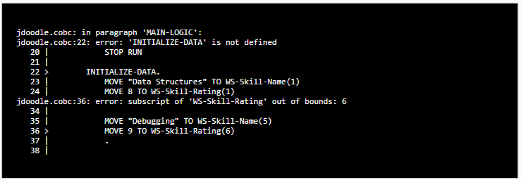

The MAIN-LOGIC paragraph is missing the full-stop after its STOP RUN statement at the end of the paragraph; this has been corrected.

On the last line of the INITIALIZE-DATA paragraph, the value 9 is moved to WS-Skill-Name(6). This table element is out of bound because the table consists of 5 elements; this has been corrected.

After applying the corrections, the program was rerun with following result.



Also, for the sake of visual clarity, the placements of the full-stops signifying the end of a paragraph were adapted to appear on a new line of their own.